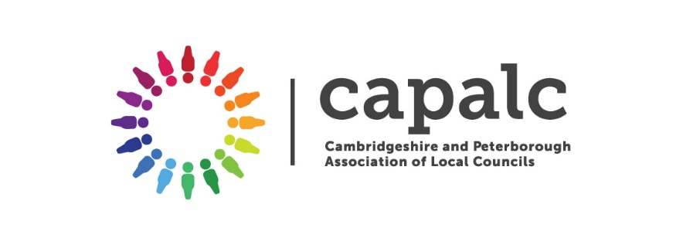 | CAPALC Ltd  The Norwood Building  Parkhall Road  Somersham  Huntingdon  PE28 3HE  Tel: 07507 520849  www.capalc.org.uk  office@capalc.org.uk

Cambridgeshire & Peterborough Association of Local Councils
_______________________________________________________________________________________

Northstowe Town Council
Northstowe
Cambridgeshire

6th December 2021

To Members of Northstowe Town Council,

Please find attached a copy of my mid-year internal audit report for the financial year 2021-22. The report has been discussed fully with the Clerk to the Council, and a few actions, including completing the risk assessment updating the asset register, and writing a privacy notice for parish council emails, will be completed by the time of the Annual Audit. A full report on the finances and AGAR will be carried out in April 2022.

You will also note that some of the areas have not been checked as they are not relevant at this time (document disposal/archiving, updating Register of Interest forms). It is hoped that a face to face meeting will be held in April when I will be able to inspect the minutes and other documents more easily.

Yours faithfully

D M Bayliss

Diane Bayliss
Senior Development Officer
Internal Auditor
CAPALC

