Commercial Café @ The Unity Centre, Northstowe, Cambridge
  - Tender Document

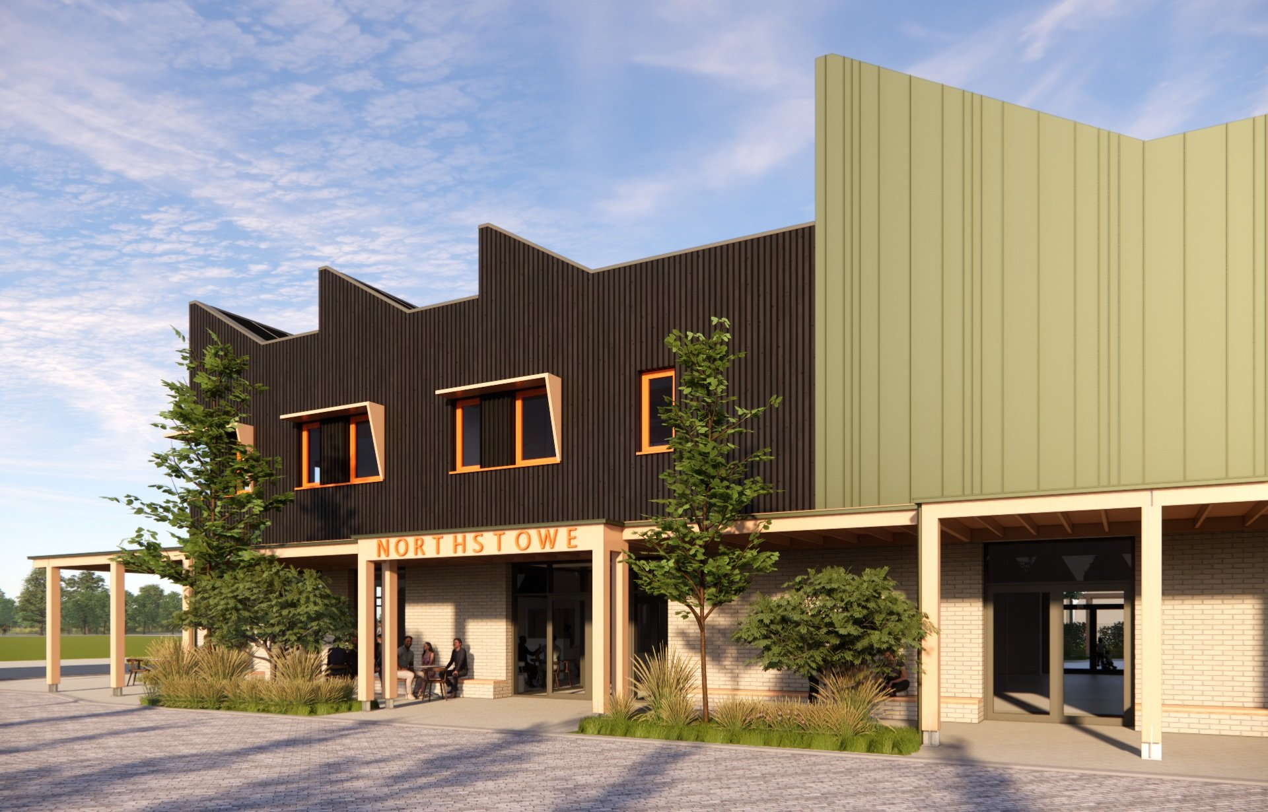

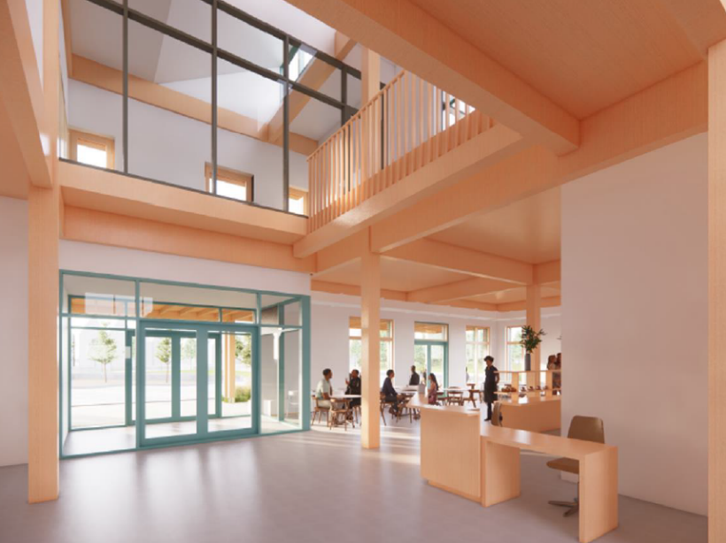

Section 1
Publication date: | Wednesday 26th November 2025
Return date & time: | 9:00am Wednesday 10th December 2025
ITT return address: | tender@northstowetowncouncil.gov.uk
Contact Officer | Huw Walters
Contact Officer Telephone: | 07943 500315
Contact Officer E-mail: | Huw.walters@northstowetowncouncil.gov.uk
Submission requirements: | Tender Pack including documents as requested within the form.
Evaluation date: | Thursday 11th December 2025
Award confirmation date: | Tuesday 16th December 2025

Background and contract information
- The Unity Centre is a new community facility for Northstowe being delivered by South Cambridgeshire District Council (SCDC). Part of the facility will provide space for the Unity Centre Café for which an Operator is sought. It is envisaged that the café will be part of a lively and inclusive space designed to serve Northstowe’s growing population, which will eventually include both residents and an additional workforce associated with the nearby Enterprise Zone.
- Northstowe is a new town with a projected final population of c 26,000 once all development is completed. The current population has reached c. 2,700 and is already a thriving town with numerous community groups already buying into the ‘sustainable & green’ ethos. More information can be found here www.northstowetownCouncil.gov.uk
- The opportunity encompasses the use of the café space, adjacent kitchen, and an external seating area. Operators will also have access to shared facilities and the chance to engage with community activities within the building and the adjoining outdoor spaces. As Northstowe’s population grows and incorporates commercial activity, as well as residential development, we anticipate the Unity Centre growing as a community focal point.
- The Town Council is working towards a lease from SCDC to operate the building, including the café space and anticipate this being concluded prior to practical completion of the Unity Centre which is programmed for February/March 2026. Any financial matter will be subject to the Town Council’s financial regulations.

Objectives of the tender

The aim of the tender is to appoint a suitable commercial Operator for the café space who will:
- Provide high-quality catering services that complement the Unity Centre’s community role and the diverse community it will serve.
- Submit a business model that delivers a sustainable return to the Council.
- Tenderers must propose a fixed annual rent, indexed annually by RPI.
- Support the aims and activities of the Unity Centre which may include arranging events, hosting community groups and partnering with local businesses where appropriate.
- Offer operational flexibility to support community and event usage of the Centre.
- Align with the Council’s standards of governance, financial probity, and operational delivery.

Tender evaluation
Tender evaluations will be conducted in accordance with Appendix 1 – Tender Evaluation Framework.

The tender evaluation will be split as per the below Matrix:

Should a tender include arithmetical errors the tenderer will be given the opportunity to correct these. Correction will be the only option allowed, and this must be made through ‘tracked changes’ so that the evaluation panel is able to see what has been amended.

Northstowe Town Council reserves the right to not accept any given tender.

Key Specification and Requirements

Operator Services

Northstowe Town Council has identified its key objectives of the Unity Centre Café to be,

- Quality
  - To supply a wide choice of high quality, nutritious and healthy food, beverage, and refreshment at agreed times, giving good value for money and within budget which reflect well on the Operator and the Council.

- Wellness
  - Community wellness is at the heart of the expected purpose of the café operation incorporating the benefits of the Northstowe environment which should be promoted and supported.

- Efficiency
  - To provide an efficient catering option that meets the requirements of all visitors to the Unity Centre Café

- Delegation
  - To delegate the operational responsibilities of the Cafe to the Operator who will respond efficiently and effectively to those needs.

- Management
  - To ensure that the manager of the premises is a well-qualified professional with a proven track record, able to communicate with visitors and who will take a pro-active approach in assisting in the provision of a first-class service.

- Innovation
  - To ensure the catering service is provided by a dedicated and appropriately trained staff, offering enthusiasm, creativity, and innovation and to supply a stimulating range of food options based on fresh and wholesome produce.

- Environment
  - To provide a welcoming environment for all visitors, providing flexibility wherever possible.

- Openness
  - To ensure that all records are open for inspection by Northstowe Town Council or their nominated representative at all reasonable times. Northstowe Town Council are to receive financial reports, quarterly and is to be kept informed of the full facts of the catering services including sales and operations at all times.

Tender Delivery Specification

Contract/Service Standards:

Minimum operating hours are to be derived by the tenderer with the usual opening hours of the Unity Centre being from 9am to 9pm on weekdays and a Saturday with the hours of operation on Sunday being from 10am to 5pm. Additional event coverage as and when needed would be preferable.

The Operator must maintain high hygiene standards in collaboration with the Town Council to ensure Unity Centre’s overall cleanliness. Staff training and continuous development are expected and initiatives for town residents to gain work experience will be supported.

Catering Services Information:

The Town Council will provide a secure, well-maintained operating building, with the café Operator occupying designated ground floor areas including the dining area, servery/counter, and kitchen.

It is anticipated that the internal café dining area will provide comfortable space for circa fifty covers. It is intended that the café spaces will be provided with heating, lighting, power, and Wi-Fi provision. The provision for a micro-library is also an essential requirement that the Town Council would like to see incorporated.

The café Operator will be responsible for the following elements, financially and practically:

- Catering kitchen fit out (appropriate water, waste and electrical service will be provided;
- Servery/Counter supply & fit including all associated fittings;
- Café furniture & fittings including internal and external seating.

Tenderers are required to design their own menu(s) to provide food & beverages appropriate to the day time use of the building.

It is envisaged that the café will be a social space where the community can enjoy speciality coffee, seasonal food together with handcrafted breads, pastries, cakes, and treats. Recognition of the diverse cultural population of the town should be reflected in the menus provided.

In addition to the regular menu provision, it is expected that bespoke catering for events should be offered and provided.

Inclusivity for all is a central consideration and we would like to see, in addition to being addressed through your menus how you might communicate this through your interaction with the community.

The Operator is to use their own packaging for food and beverages.

Tenderers must submit a brief business plan. Proposals should consider capital investment requirements and sustainability measures must also be addressed in the offer.

Company Information

The tenderer will be required to provide the following information:

- Company legal documentation.
- Financial accounts for the past 3 years.
- Health and safety credentials.
- Hygiene accreditation.
- Business Plan for the Unity Centre Café.
- Completed Form of Tender.

Once the Council has advised the preferred tenderer of their acceptance it is the intention that they will provide legal Heads of Terms for consideration and the lease agreement. In order for the café Operator to commence their fit out works this will be a priority for the Town Council. The basis of any agreement will be 6-year lease agreement based on a fixed-fee rental income indexed by RPI, annually. There will be scope to increase this agreement to a 10-year period, subject to negotiations.

It is anticipated that the Unity Centre will be completed and handed to South Cambridgeshire District Council at the end of February with the café kitchen available at that point for fitting out. Prior to that, and as soon as possible in 2026, it is envisaged that the preferred Operator, together with their contractors, will be provided access to the building to carry out surveys etc. This will be with arranged via Northstowe Town Council, South Cambridgeshire District Council and their contractor Kier. No preparatory work is envisaged prior to the completion of the construction contract.

Service Standards

- All service must be prompt, friendly and efficient, recognising the needs and circumstances of the customer. All advertised hours of the service must be adhered to. It is essential that the Operator is flexible and responsive to the service needs of the visitors. Changes may be required at relatively short notice. All service provisions must meet all current and future Food Hygiene and HSE regulations and the Operator must always adhere to the current legislation and sector best practice.

- Allergen compliance in relation to all food and preparation area, appropriately trained staff to deal with customer requests for information about allergens. The Operator must inform Northstowe Town Council of any reports of their business activities resulting from any visits by the Department of Environmental Health within 24 Hours.

- The Operator must ensure that all personnel are clearly identifiable whilst on Northstowe Town Council’s premises. Northstowe Town Council wishes to partner an organisation who can proactively manage cost areas whilst attaining and maintaining high quality service levels within the Unity Centre Cafe.

It is important to repeat that the cafe Operator will be expected to bear all costs in relation to the fitting out and furnishing of the commercial café including the kitchen, servery/counter area. Water supply, heating, drainage and Wi-Fi will be included but subject to a re-charge services agreement. This will be expected to be demonstrated within the tender document and business plan by the prospective tenderer.

Further contract Information
- This contract is subject to the Cabinet Office’s Procurement Policy Note 11/20 reserving below threshold procurements and is only open to those suppliers whose businesses are located in the geographical area of South Cambridgeshire District Council. Northstowe Town Council’s Financial Regulations apply at all times including Appendix 1 of the Financial Regulations. We anticipate this contract being under the value £30,000 per annum including VAT.
- This contract is for a minimum of 6 years term with a formal lease agreement which could rise to 10 years subject to negotiation.
- The lease will fall outside the Landlord & Tenant Act 1954 (Sections 24–28), so there is no automatic right to renewal.

- No structural alterations may be made without written consent.

- Noise and disruption must be minimised due to the proximity of residences; operational hours and restrictions will be specified in the lease.

- No compensation will be offered for tenant improvements.

- Rent deposits or guarantors may be requested depending on financial standing.

- Security arrangements must consider the site’s open-access nature.

- The tenant must indemnify Northstowe Town Council against liabilities or claims resulting from use.

- Although South Cambridgeshire District Council will retain short-term land ownership, this will transition to Northstowe Town Council in due course. The Operator (tenant) will assume full responsibility for maintenance, insurance, utilities, and all operational costs related to the unit and outdoor areas used.

- Northstowe Town Council will maintain the remaining spaces, but there may be opportunities for the Operator to discuss usage and maintenance of these shared areas. Further discussions will be needed regarding the specifics of utilities, insurance, public liability, and repair and maintenance responsibilities.

- Northstowe Town Council will be responsible for building security. The Operator will enter into a formal lease with Northstowe Town Council. Importantly, the site cannot be used solely for commercial purposes; its primary function is as a community hub that promotes social interaction and inclusivity.

- Northstowe Town Council is open to variations in the proposed operating model, provided that the café ensures inclusive access for community groups and clubs, remains open at weekends throughout the year, and operates seven days per week.

- Detailed architectural plans are available. The building is expected to be completed by February or March 2026, after which the chosen Operator may commence fit-out and begin trading. The Operator will have opportunities to liaise with Northstowe Town Council and contractors regarding the practical use of the building, within the context of any pre-existing agreements or contracts.

- The Operator will be responsible for the removal of all waste to the designated area as specified by Northstowe Town Council.

- The staff of the successful Operator will be able to use the public amenities located in the building.

- The tenderer should note that the award of this contract will be made subject to contract and lease agreement.

- Assuming the lease extends to 7 years or beyond it is a requirement that the tenderer bears responsibility for all legal costs, stamp duty and registration fees.

Information to include in your response.
- The information that you provide should let us know how your company intends to provide the services described in the ‘Description of Services’ section. In particular it should include:
  - Anticipated capital cost schedule.
  - How your firm will manage the delivery of the services contained within this tender and where from;
  - Details of the team that will provide the services and a summary of their experience (including CV’s);
  - Examples of similar business enterprise that clearly demonstrate expertise in profitable café operation , community engagement all based on providing a quality catering provision.
  - Social & Community Value

TENDER DOCUMENTS

Tenderers should note that it is a mandatory requirement that Tender Documents 1 to 4 are completed and returned as part of the tender submission. A Form of Tender should also be returned.

It is assumed that all financial amounts are given exclusive of VAT.

Tender Document ONE – CATERING OFFER
Please complete this form to state what you will be offering to serve.

All Day Beverages | Breakfast Offer
Lunch Offer | Snacks, Sweets and Desserts

Tender Document TWO – OPENING HOURS AND EVENTS

Please complete this form to state what your proposed hours of trading would be.

 | Monday | Tuesday | Wednesday | Thursday | Friday | Saturday | Sunday
Open
Close

Would you be willing to open late for special events throughout the year?

Do you foresee being closed on any dates throughout the year? If so, please specify.

Would your provision be open on a Bank Holiday/Public Holiday?

Do you foresee any seasonal opening hours being operated? If so, please specify.

Do you foresee arranging community events ( please provide examples)

Tender Document THREE – TENDER PRICING
To The Town Clerk of Northstowe Town Council,

Having examined the specification for the performance of the services as listed in this document, we offer to pay to the Council, excluding VAT, the sum of £_________ per annum (£_______ per month) commencing _____ months from the contract commencement.

This assumes an initial capital outlay of £ ___________

TABLE ONE – YOUR TENDER

Year | Investment | Overheads (staff, running costs etc) | Cost of Stock | Expected Sales | Profit (sales minus investment, overheads, and stock) | Lease Payment to the Council
1 |  |  |  |  |  | £
2
3
4
5
6
Total | £ | £ | £ | £ | £ | £

TABLE TWO – HOW TO COMPLETE TABLE ONE

Year | Investment | Overheads (staff, running costs etc) | Cost of Stock | Expected Sales | Profit (sales minus investment, overheads, and stock) | Payment to the Council
1 | £5000 | £6000 | £5000 | £25,000 | £9000 | £8,400
2 | £0 | £7000 | £6000 | £26,000 | £13,000 | £8,400
3 | £0 | £8000 | £7000 | £27,000 | £12,000 | £8,400
Total | £5000 | £39,000 | £18,000 | £78,000 | £15,000 | £25,200

The figures provided are here for evaluation purposes only, based on the expectation that with the right company the café will be a success. The Council does not guarantee any sales, profits or numbers of people that may attend the

Tender Document FOUR – YOUR BUSINESS

Company Name
Trading name if different from above
Company Registration Number
VAT Registration Number
Website Address
Company Address
Telephone
Person Responsible

Is your organisation.
Public Limited Company? |  | Sole Trader?
LLP? |  | Limited Company?
Trading Partnership? |  | CIC?

Please supply the following details:
Date Formed
Turnover per annum
Number of employees
Number of sub-contractors

Please give details of your insurance cover:
Public Liability (minimum £5m) | £
Employers Liability ( minimum £10m) | £
Please supply a copy of the relevant certificates.

Checklist

Please attach the below items to your tender form:
Completed Tender Document including:
- Tender Document One
- Tender Document Two
- Tender Document Three
- Tender Document Four
- Form of Tender (signed)
Current Hygiene Accreditation
Business Plan for the Unity Centre Cafe
Bank Statement dated within the last three months.
Annual Accounts for three most recent financial years.

Appendix 1 – Tender Evaluation Framework

Tender Evaluation and Award Criteria

Assessment Framework for Tender Submission

2.1 Compliance Check
Each Tender will undergo an initial review to ensure compliance with all requirements outlined in the Tender requirements. Any Tender failing to meet these fundamental requirements may be excluded from further evaluation.

2.2 Evaluation Against Award Criteria
Tenders that pass the compliance check will be evaluated according to the following scoring criteria:

Scoring Criteria
Score | Description
0 | Major non-compliance with requirements. Evidence is unacceptable or non-existent. There is a failure to properly address issues or meet any of the requirements, or no information is provided.
1 | Does not meet requirements. Major deficiencies or concerns exist in certain areas, or the lack of detail and relevance requires the reviewer to make assumptions.
2 | Meets requirements. Minor deficiencies or concerns in information provided but may be adaptable.
3 | Meets requirements. Adequate relevant detail provides a comprehensive response demonstrating fully how requirements will be met.
4 | Exceeds requirements. A comprehensive response which meets all requirements and offers some added value.

Pass/Fail Assessment Criteria
In addition to the scoring criteria above, the following aspects will be assessed on a Pass/Fail basis:
- Insurance
- Food Hygiene Rating
- Health and Safety
- Equalities
Failure to achieve a 'Pass' in any of these areas may result in the Tender being disqualified from further consideration.

Scoring Matrix

Appendix 2 – Site Plan

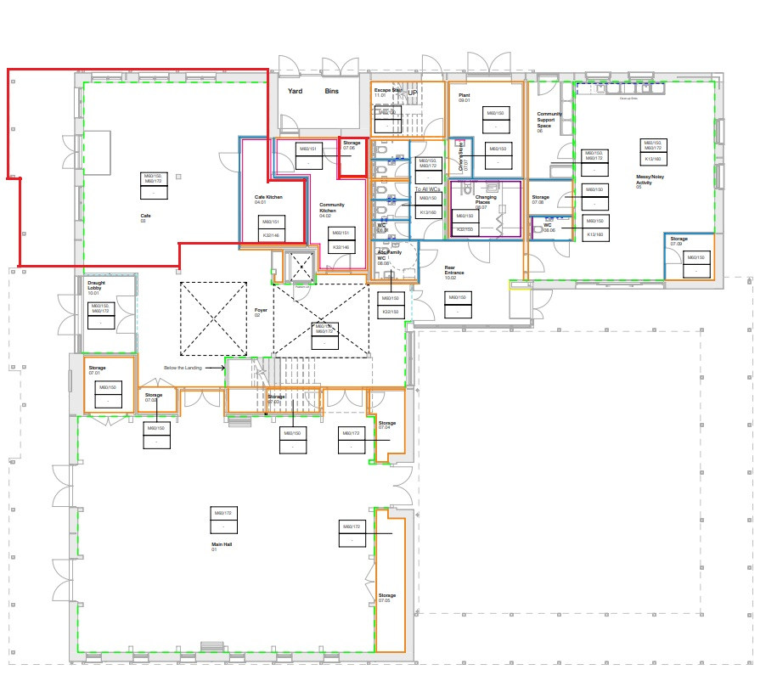

Appendix 3 – Form of Tender (to be signed by prospective tenderer)

FORM OF TENDER

Unity Centre – Commercial Café Operator

I/We the undersigned hereby submit this Tender and offer to enter into a Lease to occupy and operate the commercial café space within the Unity Centre, Northstowe, as described in the Tender Documents and shown on the plan at Appendix 2.

I/We understand that the Council intends to grant a lease commencing April 2026, subject to the execution of the Town Council’s head lease with South Cambridgeshire District Council and completion of all legal due diligence.

I/We further understand that this Tender constitutes a binding and irrevocable offer for 120 days from the submission deadline.

1. Financial Submission
I/We hereby offer the following annual rent for a 6-year Lease of the café premises:

(Please complete all years in the table below.

Lease Year | Annual Rent Offered (£)
1st Year – 2026 | £________________________
2nd Year – 2027 | £________________________
3rd Year – 2028 | £________________________
4th Year – 2029 | £________________________
5th Year – 2030 | £________________________
6th Year – 2031 | £________________________
Rent Indexation:
I/We understand that an annual rental uplift will be applied in accordance with the method set out in the draft Heads of Terms (e.g., CPI/RPI), and that this uplift is separate from and not reduced by any recovery of capital costs.

2. Conditions of Tender
By submitting this Tender, I/We expressly acknowledge, accept, and agree to the following conditions:

General
- All tenders relate solely to the café area shown on the indicative plan at Appendix 2.
- Tenders will be evaluated using the Council’s approved Quality & Financial Scoring Matrix (Appendix 1) in accordance with Northstowe Town Council’s Financial Regulations.
- Tenders must be completed in full and submitted strictly in accordance with the instructions set out in the Tender Documents.

Variations
- Any proposed variations, qualifications, or additions to the standard Heads of Terms must be submitted separately in writing and clearly marked as such.

Insurance & Responsibilities
- The successful tenderer shall be responsible for arranging and maintaining all required operational, public liability, contents, and employer insurances.

- The tenderer confirms that they have examined all plans and tender documents and fully understand the operator’s responsibility for complete fit-out, equipment provision, maintenance, utilities, and operational costs.

Furniture & Structures
- Tenderers must clearly describe the type, style, and specification of any proposed furniture, fittings, or structures (internal or external).

Council’s Rights
- Northstowe Town Council is not obliged to accept the highest, lowest, or any tender received.

- The Council reserves the right to seek clarifications, request further information, or discontinue the tender at any time.

3. Tenderer’s Declaration
This Tender constitutes an irrevocable offer for 120 days and, if accepted within that period, shall form a binding agreement in principle between the Tenderer and Northstowe Town Council, subject to:

- completion of legal documentation
- execution of the Council’s head lease with South Cambridgeshire District Council
- approval by Northstowe Town Council
- satisfactory completion of due diligence

I/We confirm that:
- All information provided in this Tender is accurate and complete.
- No canvassing, discussion, or contact has been made with any Councillor.
- No attempt has been made to improperly influence the tender process.
- I/We understand that misrepresentation may result in immediate disqualification.
- I/We agree to comply fully with all Conditions of Tender and all requirements described in the Tender Documents.

4. Tenderer Details
Signed by: ___________________________________________
Full Name (print): ______________________________________
Position: ______________________________________________
Company Legal Name: ___________________________________
Registered Address:

Telephone: ____________________________________________
Email: ________________________________________________
Date: ___________________________

5. Submission Instructions
All Tenders must be submitted:

By email to:
tender@northstowetowncouncil.gov.uk
No other form of submission will be accepted.
Tenders sent to Councillors, personal email accounts, or alternative addresses will be rejected.

